PRE-K HOME LEARNING
June 1st-5th, 2020
CHOICE BOARD
CELEBRATING YOU
Choose an activity to do each day. Don’t worry about crossing off the activities after you have finished. You can do these activities multiple times. Here is the last board for the school year, please visit all the other boards we have posted and do the activities as many times as you would like throughout the summer months! Kindergarten here we come!!!!!!
Reading | Math | Science | Movement | Creativity
This week while reading from home, let’s predict what will happen next in the story. After you read each page, make your prediction. Turn the page, read and  Check to see if your prediction was close. When you are finished reading, talk to someone at home and tell them if you liked the story and why. These are some things that you will do next year in Kindergarten!  *********************  Here is a fun story about heading to Kindergarten:  https://youtu.be/4jPtK1cHqDc  *********************Listen to “Miss Bindergarten Gets Ready for Kindergarten”  https://www.youtube.com/watch?v=mTK5LdlFIzk  *********************  Listen to “The Night Before Kindergarten”  https://www.youtube.com/watch?v=K4olutD-0BM  ******************** | In this story: Ten Magic Butterflies, learn about being yourself and count along to the numbers  1-10.  https://youtu.be/kBi_RoXKVo0  ********************  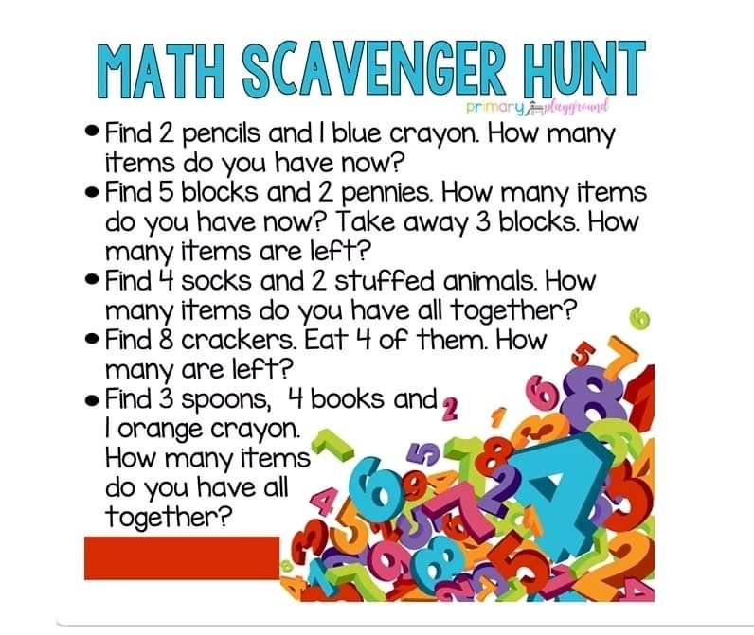  ********************  Celebrate You by Building an Edible snack Tower, Shapes, Numbers Letters, and Your Name!  -Use snack foods like mini marshmallows,  Cut-up apples, bananas, cheese chunks, then  toothpicks to build your creations –  Count how many apple and Banana pieces, cheese chunks and marshmallows to make your creations - Then EAT: (How many did you count?)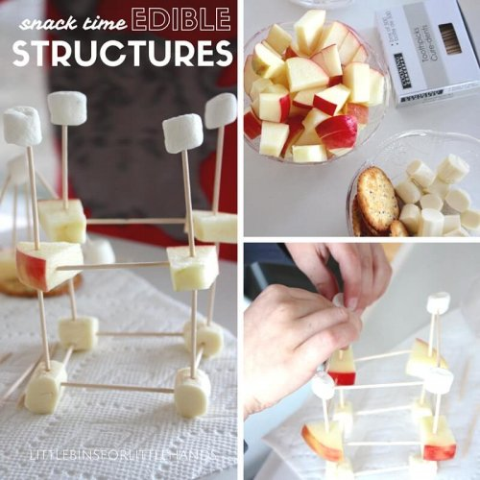https://littlebinsforlittlehands.com/edible-structures-for-snack-time-stem/ | Here are 10 easy science experiments you can do at home with your children.........have fun!  https://www.youtube.com/watch?v=4MHn9Q5NtdY  *********************  Celebrate the end of PreK by making ice cream in a bag at home!  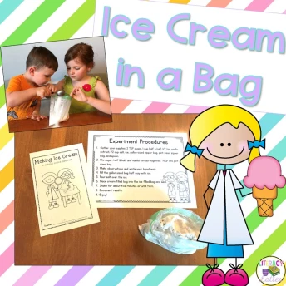  https://literacyandlattes.com/2017/05/26/how-to-make-ice-cream-in-a-bag/?utm_medium=social&utm_source=pinterest&utm_campaign=tailwind_tribes&utm_content=tribes  *********************Take a virtual trip to the national zoo!  https://nationalzoo.si.edu/webcams  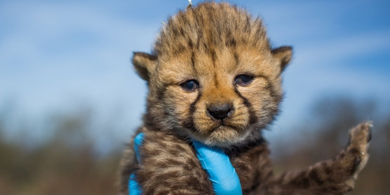  ******************** | Here is a great song about moving up to Kindergarten  https://www.youtube.com/watch?v=3A5Em_XBmpk  *********************  Dance around to this song and celebrate you and what all you have achieved this year we are all so proud of you!  https://www.youtube.com/watch?v=UWLIgjB9gGw  *********************  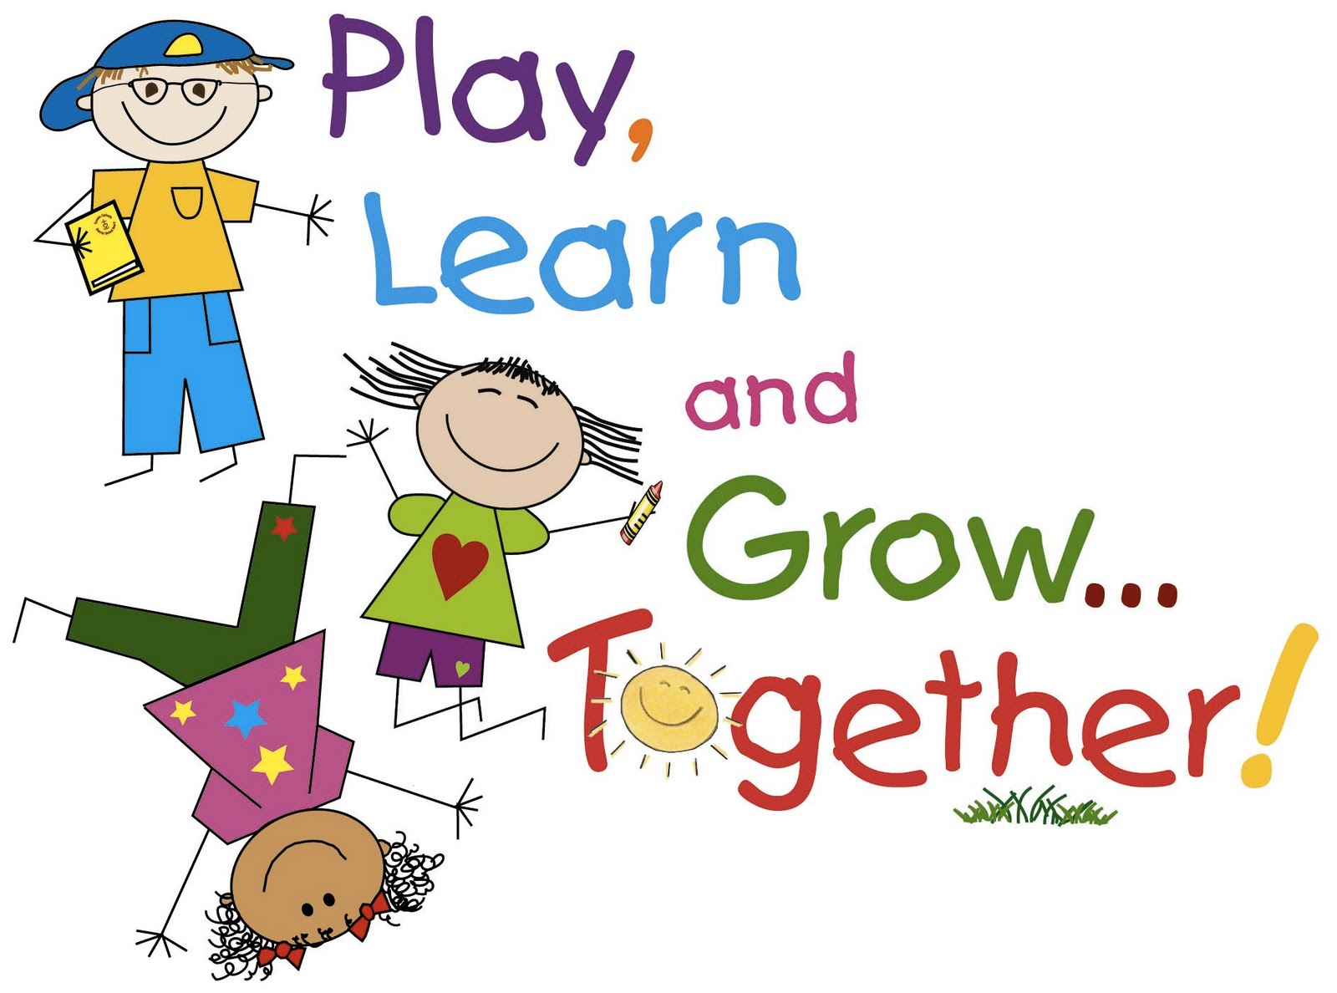  What do you want to be when you grow up? No matter what you choose, you will make us proud! Listen to this song, and start dreaming!  https://www.youtube.com/watch?v=e0hPcEgK94Y  *********************  Even though we’ve been apart and were not able to finish the school year together, we hope you have made a few great friends in Pre-K. We miss you!  You’ve Got a Friend in Me!  https://www.youtube.com/watch?v=EcXURC_nNhc  *******************  Go for a walk as a family, take a bike ride, play outside (tag, jump ropes, hula hoops, chalk, catch, play with bubbles, draw and play hopscotch. Get out and get moving the weather is perfect for all of these things! | Tell an adult what you want to be when you grow up. Draw a picture of you as a firefighter, doctor, dancer, or whatever you choose to be 😊  *******************  Individually write the 26 letters of the alphabet you have learned on a post it or small piece of paper. Look throughout your house for an item that begins with each letter!  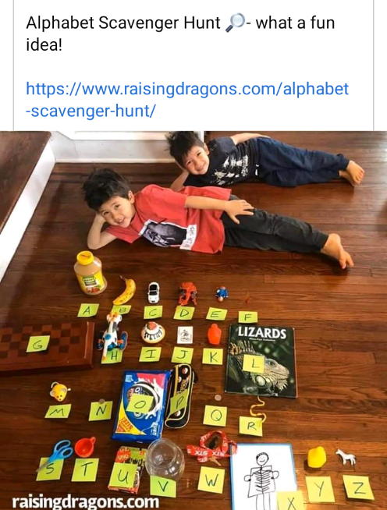  *******************  Make A Pre-K Memento  After listening to this special story about being you, paint some rocks and make your own special you, your family & pre-k friends! Make the World a Better Place!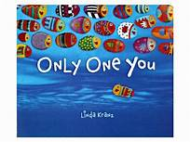https://youtu.be/v8tN1CQp_jY  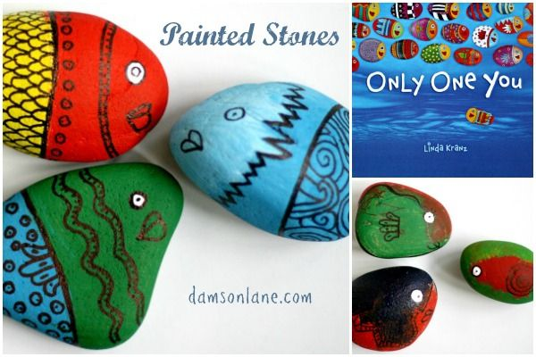
Watch Playtime LIVE! on YouTube at https://www.youtube.com/playlist… or on the Playhouse website at erieplayhouseplaytime.com/live  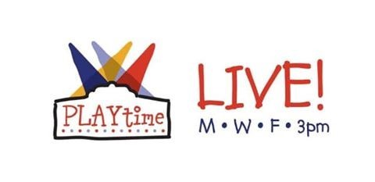*********************  Please join the WQLN Homeroom Monday through Friday from 8:00-12:00. The schedule is as follows:  Pre-K – 8:00-8:30  Science -11:30-12:00  *****************  Also visit WQLN.org under the Learning Tab for: PBS Learning Media for more fun activities. | Help sort the dinosaurs into the home that matches their size.  https://pbskids.org/dinosaurtrain/games/allstarsorting.html  *********************  Help baby fox build his machine.  https://pbskids.org/peg/games/baby-fox-machine | “Celebrate You” after watching this video- Baking A Cake with Science.....BAKE & EAT!  https://youtu.be/KrikPxd-NXs | Our Wishes for You – Sing & Move Along and be Strong:  One Small Voice | ASL | Jack Hartmann  https://youtu.be/Kn54ZzC5XK8 | 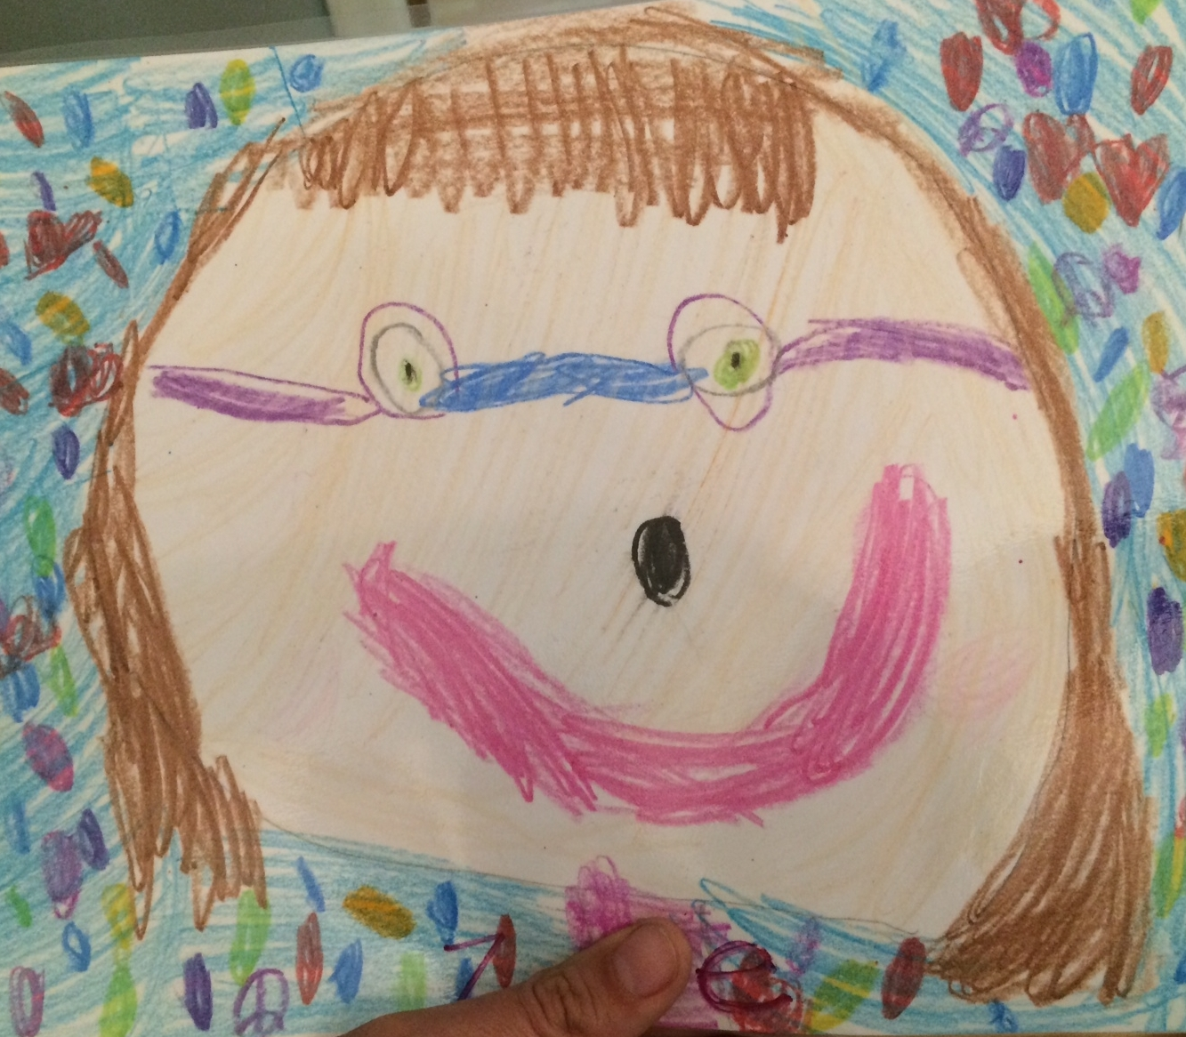  Do you remember when you drew your self-portrait at the beginning of the year?  Now that you are at the end of the school year, draw a self-portrait of what you look like now! Have Mom or Dad send a picture of you with your self-portrait to your teacher so we can see your older “Ready for Kindergarten” self!

